Electronic Supplementary Material
Influence of climatic conditions and hazelnut farming on the temporal trends and spatial distribution of waterbirds at wintering grounds

Contents
Table S1. Number of individuals of each species wintering at Lake Vico in 2009-2025. For each species, taxonomic groups and diet are shown.
Table S2. GAMs built to explore the temporal trend of wintering aquatic birds at Lake Vico (Central Italy) in 2009-2025, in relation to the year, air temperature (TEMP; °C), air pressure (PRESS; hPA), precipitation (PREC; mm), and NAO index. For each model, degrees of freedom (df), AICc and their difference with the lowest (ΔAICc), and Akaike’s weights (Σw_{i}) are shown. Models are sorted by AICc; the best model is in bold. Summary of the first derivatives of the smooth term is reported. Derivatives were used to quantify the direction and magnitude of temporal change. Values represent averages across periods with significantly negative, positive, or non-significant trends, based on 95% confidence intervals of the derivatives. A derivative was considered significant when its confidence interval did not overlap zero. If the best model was a GAM, effective degrees of freedom (EDF), F-test and its significance (P) are shown, as well as deviance explained D² and the mean and maximum autocorrelation values (ACF).
Table S3. GLMMs built to explore the spatial distribution of wintering aquatic birds at Lake Vico (Central Italy) in 2014-2025. For each model, degrees of freedom (df), AICc and their difference with the lowest (ΔAICc), and Akaike’s weights (Σw_{i}) are shown. Models are sorted by AICc; the best model is in bold. Summary of the best model is shown (estimates, standard error (SE), lower (LCI) and upper (UCI) 95% confidence intervals); variance and standard deviation (SD) of the random effect is shown. Additionally, zero-inflation test, conditional (R²c) and marginal (R²_{m}) coefficient of determination, and the mean and maximum autocorrelation values (ACF) are shown.
Figure S1. Temporal trends of wintering aquatic birds at Lake Vico in 2009-2025 (on the left) and their spatial distribution in 2014-2025 (on the right). For five species (Great Egret, Little Egret, Eurasian Moorhen, Water Rail, Marsh Harrier), only the temporal trend is shown.

Table S1. Number of individuals of each species wintering at Lake Vico in 2009-2025. For each species, taxonomic groups and diet are shown.
Species | Group | Diet | 2009 | 2010 | 2011 | 2012 | 2013 | 2014 | 2015 | 2016 | 2017 | 2018 | 2019 | 2020 | 2021 | 2022 | 2023 | 2024 | 2025
Great Crested Grebe  Podiceps cristatus | Grebe | Fish | 87 | 61 | 44 | 83 | 15 | 38 | 59 | 29 | 182 | 32 | 30 | 54 | 37 | 90 | 53 | 26 | 31
Black-necked Grebe  Podiceps nigricollis | Grebe | Invertebrates | 55 | 45 | 26 | 66 | 21 | 18 | 14 | 7 | 59 | 21 | 47 | 47 | 18 | 45 | 34 | 53 | 15
Little Grebe  Tachybaptus ruficollis | Grebe | Invertebrates | 60 | 10 | 12 | 41 | 13 | 17 | 12 | 25 | 27 | 8 | 10 | 64 | 24 | 21 | 40 | 48 | 7
Great Cormorant  Phalacrocorax carbo | Cormorant | Fish | 42 | 90 | 90 | 120 | 119 | 87 | 138 | 61 | 93 | 128 | 18 | 86 | 79 | 99 | 99 | 78 | 51
Grey Heron  Ardea cinerea | Heron | Fish | 2 | 4 | 5 | 1 | 9 | 2 | 4 | 6 | 5 | 2 | 9 | 2 | 6 | 13 | 13 | 1 | 4
Great Egret  Ardea alba | Heron | Fish | 2 | 2 | 6 | 3 | 3 | 2 | 4 | 5 | 1 | 1 | 3 | 3 | 3 | 5 | 3 | 4 | 1
Little Egret  Egretta garzetta | Heron | Fish | 0 | 0 | 0 | 0 | 2 | 0 | 0 | 1 | 0 | 1 | 0 | 1 | 4 | 2 | 7 | 0 | 0
Cattle Egret  Bubulcus ibis | Heron | Invertebrates | 0 | 0 | 0 | 0 | 0 | 0 | 0 | 0 | 0 | 0 | 0 | 0 | 4 | 5 | 2 | 0 | 3
Great Bittern  Botaurus stellaris | Heron | Fish | 0 | 0 | 0 | 0 | 0 | 0 | 0 | 0 | 0 | 0 | 0 | 0 | 0 | 0 | 1 | 0 | 0
Mallard  Anas platyrhynchos | Dabbling duck | Omnivore | 256 | 132 | 314 | 410 | 193 | 240 | 153 | 242 | 45 | 150 | 144 | 21 | 78 | 118 | 5 | 158 | 27
Eurasian Teal  Crecca crecca | Dabbling duck | Omnivore | 197 | 103 | 127 | 71 | 40 | 188 | 79 | 89 | 35 | 45 | 28 | 5 | 57 | 18 | 150 | 10 | 20
Gadwall  Mareca strepera | Dabbling duck | Herbivore | 45 | 86 | 124 | 88 | 64 | 43 | 49 | 89 | 47 | 4 | 16 | 38 | 8 | 25 | 4 | 81 | 32
Northern Pintail  Anas acuta | Dabbling duck | Omnivore | 0 | 0 | 0 | 0 | 3 | 0 | 0 | 0 | 0 | 0 | 0 | 0 | 0 | 0 | 0 | 0 | 0
Eurasian Wigeon  Mareca penelope | Dabbling duck | Herbivore | 1287 | 327 | 324 | 155 | 261 | 245 | 274 | 288 | 291 | 125 | 133 | 180 | 109 | 115 | 111 | 71 | 121
Northern Shoveler  Spatula clypeata | Dabbling duck | Omnivore | 0 | 0 | 3 | 0 | 0 | 0 | 0 | 0 | 0 | 2 | 0 | 0 | 0 | 0 | 0 | 0 | 2
Red-crested Pochard  Netta rufina | Dabbling duck | Herbivore | 0 | 1 | 0 | 1 | 4 | 0 | 0 | 0 | 0 | 0 | 3 | 114 | 0 | 12 | 0 | 0 | 0
Common Pochard  Aythya ferina | Diving duck | Omnivore | 1010 | 1162 | 349 | 1436 | 901 | 890 | 966 | 1169 | 825 | 460 | 652 | 1306 | 1009 | 347 | 738 | 53 | 135
Tufted Duck  Aythya fuligula | Diving duck | Omnivore | 513 | 832 | 496 | 444 | 275 | 321 | 392 | 635 | 599 | 141 | 686 | 314 | 615 | 442 | 229 | 109 | 152
Ferruginous Duck  Aythya nyroca | Diving duk | Herbivore | 0 | 1 | 3 | 0 | 1 | 14 | 1 | 0 | 8 | 0 | 0 | 0 | 0 | 0 | 0 | 0 | 0
Eurasian Coot  Fulica atra | Coot | Omnivore | 5019 | 3575 | 2048 | 3455 | 1136 | 2248 | 1810 | 1620 | 1604 | 3463 | 2392 | 2581 | 2083 | 1869 | 1925 | 1367 | 1247
Eurasian Moorhen  Gallinula chloropus | Rail | Omnivore | 6 | 1 | 2 | 5 | 0 | 1 | 1 | 3 | 1 | 0 | 0 | 2 | 2 | 3 | 1 | 2 | 5
Water Rail  Rallus aquaticus | Rail | Omnivore | 5 | 3 | 0 | 2 | 0 | 0 | 0 | 2 | 0 | 0 | 0 | 1 | 1 | 1 | 0 | 0 | 3
Common Greenshank  Tringa nebularia | Wader | Invertebrates | 0 | 0 | 0 | 0 | 0 | 0 | 0 | 0 | 0 | 0 | 0 | 0 | 0 | 0 | 0 | 1 | 0
Common Snipe  Gallinago gallinago | Wader | Invertebrates | 10 | 5 | 16 | 20 | 5 | 22 | 8 | 19 | 25 | 9 | 4 | 11 | 8 | 26 | 9 | 16 | 1
Black-headed Gull  Chroicocephalus ridibundus | Gull | Omnivore | 15 | 53 | 5 | 30 | 101 | 3 | 1 | 9 | 12 | 33 | 35 | 70 | 22 | 40 | 29 | 15 | 14
Yellow-legged Gull  Larus michahelllis | Gull | Omnivore | 37 | 10 | 27 | 19 | 24 | 2 | 62 | 10 | 4 | 15 | 17 | 24 | 17 | 10 | 16 | 18 | 29
Marsh harrier  Circus eruginosus | Raptor | Other vertebrates | 3 | 3 | 5 | 3 | 2 | 5 | 3 | 2 | 1 | 2 | 0 | 1 | 1 | 1 | 1 | 0 | 0

Table S2. GAMs built to explore the temporal trend of wintering aquatic birds at Lake Vico (Central Italy) in 2009-2025, in relation to the year, air temperature (TEMP; °C), air pressure (PRESS; hPA), precipitation (PREC; mm), and NAO index. For each model, degrees of freedom (df), AICc and their difference with the lowest (ΔAICc), and Akaike’s weights (Σw_{i}) are shown. Models are sorted by AICc; the best model is in bold. Summary of the first derivatives of the smooth term is reported. Derivatives were used to quantify the direction and magnitude of temporal change. Values represent averages across periods with significantly negative, positive, or non-significant trends, based on 95% confidence intervals of the derivatives. A derivative was considered significant when its confidence interval did not overlap zero. If the best model was a GAM, effective degrees of freedom (EDF), F-test and its significance (P) are shown, as well as deviance explained D² and the mean and maximum autocorrelation values (ACF).
Species | Model | df | AICc | ΔAICc | Σwi
Great Crested Grebe | Null | 2 | 176.9 | 0.00 | 0.656
Podiceps cristatus | YEAR | 3 | 179.5 | 2.52 | 0.186
 | PREC + YEAR | 4 | 182.0 | 5.08 | 0.052
 | PRESS + YEAR | 4 | 182.5 | 5.60 | 0.040
 | TEMP + YEAR | 4 | 182.9 | 5.97 | 0.033
 | NAO + YEAR | 4 | 182.9 | 5.98 | 0.033
Not significant trend
Intercept = 55.94 ± 9.55
Black-necked Grebe | Null | 1 | 151.1 | 0.00 | 0.696
Podiceps nigricollis | YEAR | 3 | 153.9 | 2.78 | 0.174
 | PREC + YEAR | 4 | 157.0 | 5.87 | 0.037
 | TEMP + YEAR | 4 | 157.1 | 5.98 | 0.035
 | PRESS + YEAR | 4 | 157.2 | 6.12 | 0.033
 | NAO + YEAR | 4 | 157.7 | 6.63 | 0.025
Not significant trend
Intercept = 34.77 ± 4.47
Little Grebe | Null | 1 | 151.0 | 0.00 | 0.701
Tachybaptus ruficollis | YEAR | 3 | 153.9 | 2.95 | 0.161
 | NAO + YEAR | 4 | 156.6 | 5.68 | 0.041
 | TEMP + YEAR | 4 | 156.7 | 5.74 | 0.040
 | PREC + YEAR | 4 | 157.3 | 6.38 | 0.029
 | PRESS + YEAR | 4 | 157.4 | 6.43 | 0.028
Not significant trend
Intercept = 25.82 ± 4.45
Great Cormorant | Null | 2 | 169.1 | 0.00 | 0.675
Phalacrocorax carbo | YEAR | 3 | 172.4 | 3.27 | 0.132
 | NAO + YEAR | 4 | 173.4 | 4.26 | 0.080
 | TEMP + YEAR | 4 | 174.0 | 4.89 | 0.058
 | PRESS + YEAR | 4 | 175.2 | 6.11 | 0.032
 | PREC + YEAR | 4 | 175.8 | 6.73 | 0.023
Not significant trend
Intercept = 86.94 ± 7.58
Grey Heron | Null | 2 | 97.6 | 0.00 | 0.474
Ardea cinerea | YEAR | 3 | 98.8 | 1.21 | 0.258
 | PREC + YEAR | 4 | 100.9 | 3.33 | 0.090
 | NAO + YEAR | 4 | 101.2 | 3.63 | 0.077
 | TEMP + YEAR | 4 | 101.9 | 4.32 | 0.055
 | PRESS + YEAR | 4 | 102.2 | 4.67 | 0.046
Not significant trend
Intercept = 5.18 ± 0.92
Great Egret | Null | 2 | 64.9 | 0.00 | 0.689
Ardea alba | YEAR | 3 | 67.8 | 2.96 | 0.157
 | PRESS + YEAR | 4 | 69.9 | 4.98 | 0.057
 | TEMP + YEAR | 4 | 70.6 | 5.68 | 0.040
 | PREC + YEAR | 4 | 71.2 | 6.30 | 0.029
 | NAO + YEAR | 4 | 71.3 | 6.44 | 0.028
Not significant trend
Intercept = 3.00 ± 0.35
Little Egret | YEAR | 3 | 73.5 | 0.00 | 0.358
Egretta garzetta | Null | 2 | 73.7 | 0.20 | 0.325
 | PREC + YEAR | 4 | 75.8 | 2.38 | 0.109
 | PRESS + YEAR | 4 | 76.4 | 2.94 | 0.082
 | NAO + YEAR | 4 | 76.9 | 3.46 | 0.064
 | TEMP + YEAR | 4 | 76.9 | 3.48 | 0.063
Not significant trend
Intercept = 1.06 ± 0.43
Mallard | YEAR | 3 | 202.7 | 0.00 | 0.562
 | PREC + YEAR | 4 | 205.0 | 2.31 | 0.196
 | NAO + YEAR | 4 | 205.6 | 2.90 | 0.108
 | PRESS + YEAR | 4 | 206.5 | 3.83 | 0.068
 | TEMP + YEAR | 4 | 206.7 | 4.04 | 0.061
 | Null | 2 | 211.9 | 9.19 | 0.005
Decreasing trend
Intercept = 158.00 ± 19.76
s(YEAR) | 2009-2025 | Derivative: mean = -15.174, SE = 4.03, LCI = -23.08, UCI = -7.27
EDF = 1, F = 14.15, P = 0.002
D² = 48.5%; ACF: mean = 0.105, max = 0.227
Eurasian Teal | YEAR | 3 | 188.5 | 0.00 | 0.501
Crecca crecca | TEMP + YEAR | 4 | 191.2 | 2.69 | 0.130
 | Null | 2 | 191.6 | 3.06 | 0.108
 | PRESS + YEAR | 4 | 191.8 | 3.31 | 0.096
 | PREC + YEAR | 4 | 192.1 | 3.53 | 0.086
 | NAO + YEAR | 4 | 192.2 | 3.69 | 0.079
Decreasing trend
Intercept = 74.24 ± 12.24
s(YEAR) | 2009-2019 | Derivative: mean = -7.868, SE = 3.34, LCI = -14.41, UCI = -1.33
s(YEAR) | 2020-2025 | Derivative: mean = -5.14, SE = 3.89, LCI = -12.77, UCI = 2.48
EDF = 1.264, F = 4.56, P = 0.027
D² = 36.0%; ACF: mean = 0.185, max = 0.296
Gadwall | YEAR | 3 | 196.6 | 0.00 | 0.371
Mareca strepera | PREC + YEAR | 4 | 170.3 | 0.70 | 0.262
 | PRESS + YEAR | 4 | 172.1 | 2.52 | 0.105
 | NAO + YEAR | 4 | 172.4 | 2.81 | 0.091
 | TEMP + YEAR | 4 | 172.4 | 2.82 | 0.090
 | Null | 2 | 172.6 | 3.05 | 0.081
Decreasing trend
Intercept = 49.59 ± 7.18
s(YEAR) | 2009-2022 | Derivative: mean = -3.897, SE = 1.65, LCI = -7.14, UCI = -0.66
s(YEAR) | 2023-2025 | Derivative: mean = -3.50, SE = 1.84, LCI = -7.11, UCI = 0.11
EDF = 1.081, F = 5.58, P = 0.025
D² = 32.0%; ACF: mean = 0.122, max = 0.285
Eurasian Wigeon | YEAR | 3 | 178.7 | 0.00 | 0.525
Mareca penelope | TEMP + YEAR | 4 | 181.2 | 2.45 | 0.154
 | NAO + YEAR | 4 | 181.3 | 2.55 | 0.147
 | PRESS + YEAR | 4 | 182.3 | 3.60 | 0.087
 | PREC + YEAR | 4 | 182.3 | 3.62 | 0.086
 | Null | 2 | 192.7 | 14.00 | 0.000
Decreasing trend
Intercept = 195.62 ± 13.42
s(YEAR) | 2009-2025 | Derivative: mean = -15.044, SE = 2.91, LCI = -20.75, UCI = -9.37
EDF = 1, F = 26.70, P < 0.001
D² = 65.6%; ACF: mean = 0.155, max = 0.371
Common Pochard | YEAR | 3 | 234.6 | 0.00 | 0.468
Aythya ferina | NAO + YEAR | 4 | 235.2 | 0.56 | 0.353
 | TEMP + YEAR | 4 | 238.8 | 4.23 | 0.056
 | PREC + YEAR | 4 | 238.9 | 4.32 | 0.054
 | PRESS + YEAR | 4 | 239.1 | 4.47 | 0.050
 | Null | 2 | 241.1 | 6.46 | 0.018
Decreasing trend
Intercept = 816.19 ± 73.61
s(YEAR) | 2009-2014 | Derivative: mean = -65.48, SE = 22.60, LCI = -109.78, UCI = -21.19
s(YEAR) | 2015-2025 | Derivative: mean = -33.12, SE = 28.47, LCI = -88.91, UCI = 22.68
EDF = 1.456, F = 9.16, P = 0.008
D² = 51.2%; ACF: mean = 0.103, max = 0.412
Tufted Duck | Null | 1 | 232.2 | 0.00 | 0.40
Aythya fuligula | YEAR | 3 | 233.7 | 1.50 | 0.189
 | TEMP + YEAR | 4 | 233.8 | 1.66 | 0.174
 | PRESS + YEAR | 4 | 234.8 | 2.60 | 0.109
 | PREC + YEAR | 4 | 235.6 | 3.38 | 0.074
 | NAO + YEAR | 4 | 236.2 | 4.01 | 0.054
Not significant trend
Intercept = 423.24 ± 50.65
Eurasian Coot | YEAR | 3 | 284.9 | 0.00 | 0.523
Fulica atra | Null | 2 | 287.7 | 2.83 | 0.127
 | PREC + YEAR | 4 | 288.3 | 3.40 | 0.096
 | PRESS + YEAR | 4 | 288.4 | 3.48 | 0.092
 | TEMP + YEAR | 4 | 288.4 | 3.53 | 0.089
 | NAO + YEAR | 4 | 288.8 | 3.92 | 0.074
Decreasing trend
Intercept = 2320.1 ± 210.20
s(YEAR) | 2009-2019 | Derivative: mean = -124.38, SE = 53.64, LCI = -229.52, UCI = -19.24
s(YEAR) | 2020-2025 | Derivative: mean = -92.88, SE = 61.57, LCI = -213.56, UCI = 27.80
EDF = 1.188, F = 4.68, P = 0.029
D² = 33.5%; ACF: mean = 0.154, max = 0.381
Eurasian Moorhen | Null | 2 | 68.2 | 0.00 | 0.615
Gallinula chloropus | PRESS + YEAR | 4 | 71.5 | 3.33 | 0.116
 | YEAR | 3 | 71.7 | 3.51 | 0.106
 | PREC + YEAR | 4 | 72.4 | 4.22 | 0.075
 | NAO + YEAR | 4 | 72.4 | 4.22 | 0.074
 | TEMP + YEAR | 4 | 75.8 | 7.63 | 0.014
Not significant trend
Intercept = 2.06 ± 0.44
Water Rail | YEAR | 3 | 61.0 | 0.00 | 0.396
Rallus aquaticus | PRESS + YEAR | 4 | 61.5 | 0.49 | 0.310
 | ANO + YEAR | 4 | 62.9 | 1.95 | 0.150
 | PREC + YEAR | 4 | 64.7 | 3.79 | 0.060
 | Null | 2 | 65.3 | 4.39 | 0.044
 | TEMP + YEAR | 4 | 65.5 | 4.58 | 0.040
Fluctuating trend
Intercept = 1.059 ± 0.28
s(YEAR) | 2009-2017 | Derivative: mean = -0.389, SE = 0.121, LCI = -0.626, UCI = -0.153
s(YEAR) | 2018-2020 | Derivative: mean = -0.093, SE = 0.091, LCI = -0.084, UCI = 0.271
s(YEAR) | 2021-2025 | Derivative: mean = 0.320, SE = 0.274, LCI = 0.021, UCI = 0.620
EDF = 1.894, F = 5.09, P = 0.018
D² = 45.5%; ACF: mean = 0.084, max = 0.245
Common Snipe | Null | 2 | 121.4 | 0.00 | 0.682
Gallinago gallinago | YEAR | 3 | 124.6 | 3.23 | 0.135
 | PREC + YEAR | 4 | 126.1 | 4.70 | 0.065
 | NAO + YEAR | 4 | 126.5 | 5.16 | 0.052
 | TEMP + YEAR | 4 | 127.1 | 5.73 | 0.039
 | PRESS + YEAR | 4 | 127.8 | 6.44 | 0.027
Not significant trend
Intercept = 12.59 ± 1.86
Black-headed Gull | Null | 2 | 163.1 | 0.00 | 0.648
Chroicocephalus ridibundus | YEAR | 3 | 166.1 | 2.95 | 0.148
Chroicocephalus ridibundus | PREC + YEAR | 4 | 167.0 | 3.84 | 0.095
 | PRESS + YEAR | 4 | 168.3 | 5.19 | 0.048
 | TEMP + YEAR | 4 | 169.1 | 6.00 | 0.032
 | NAO + YEAR | 4 | 169.4 | 6.23 | 0.029
Not significant trend
Intercept = 28.65 ± 6.36
Yellow-legged Gull | Null | 2 | 141.9 | 0.00 | 0.584
Larus michahellis | TEMP + YEAR | 4 | 144.5 | 2.61 | 0.158
 | YEAR | 3 | 144.5 | 2.62 | 0.158
 | PREC + YEAR | 4 | 147.1 | 5.15 | 0.045
 | PRESS + YEAR | 4 | 147.7 | 5.76 | 0.033
 | NAO + YEAR | 4 | 148.5 | 6.54 | 0.022
Not significant trend
Intercept = 20.06 ± 3.41
Marsh harrier | YEAR | 3 | 52.7 | 0.00 | 0.459
Circus aeruginosus | PRESS + YEAR | 3 | 54.3 | 1.60 | 0.206
 | TEMP + YEAR | 4 | 54.8 | 2.07 | 0.163
 | PREC + YEAR | 4 | 55.9 | 3.22 | 0.091
 | NAO + YEAR | 4 | 56.2 | 3.48 | 0.080
 | Null | 1 | 67.2 | 14.48 | 0.000
Decreasing trend
Intercept = 1.94 ± 0.23
s(YEAR) | 2009-2025 | Derivative: mean = -0.248, SE = 0.048, LCI = -0.341, UCI = -0.154
EDF = 1, F = 26.91, P < 0.001
D² = 64.2%; ACF: mean = 0.131, max = 0.446
Table S3. GLMMs built to explore the spatial distribution of wintering aquatic birds at Lake Vico (Central Italy) in 2014-2025. For each model, degrees of freedom (df), AICc and their difference with the lowest (ΔAICc), and Akaike’s weights (Σw_{i}) are shown. Models are sorted by AICc; the best model is in bold. Summary of the best model is shown (estimates, standard error (SE), lower (LCI) and upper (UCI) 95% confidence intervals); variance and standard deviation (SD) of the random effect is shown. Additionally, zero-inflation test, conditional (R²c) and marginal (R²_{m}) coefficient of determination, and the mean and maximum autocorrelation values (ACF) are shown.
Species | Model | df | AICc | ΔAICc | Σw_{i}
Great Crested Grebe | Null | 3 | 563.5 | 0.00 | 0.769
Podiceps cristatus | HABITAT | 6 | 566.8 | 3.28 | 0.150
 | HABITAT × YEAR | 7 | 568.0 | 4.50 | 0.081
Intercept = 1.34 ± 0.34
Random effect | Site (9 levels): Variance = 0.908, SD = 0.953
Zero-inflation test, P = 0.896
Black-necked Grebe | Null | 3 | 455.0 | 0.00 | 0.525
Podiceps nigricollis | HABITAT | 6 | 455.9 | 0.83 | 0.346
 | HABITAT × YEAR | 7 | 457.9 | 2.82 | 0.128
Intercept = 1.04 ± 0.30
Random effect | Site (9 levels): Variance = 0.465, SD = 0.682
Zero-inflation test, P = 1.000
Little Grebe | Null | 3 | 321.1 | 0.00 | 0.476
Tachybaptus ruficollis | HABITAT | 6 | 321.7 | 0.66 | 0.341
 | HABITAT × YEAR | 7 | 323.0 | 1.91 | 0.183
Intercept = -1.29 ± 1.15
Random effect | Site (9 levels): Variance = 8.708, SD = 2.951
Zero-inflation test, P = 0.616
Great Cormorant | Null | 3 | 649.3 | 0.00 | 0.912
Phalacrocorax carbo | HABITAT | 6 | 654.8 | 5.53 | 0.058
 | HABITAT × YEAR | 7 | 656.0 | 6.79 | 0.031
Intercept = 1.75 ± 0.45
Random effect | Site (9 levels): Variance = 1.648, SD = 1.284
Zero-inflation test, P = 0.760
Grey Heron | HABITAT | 6 | 198.5 | 0.00 | 0.676
Ardea cinerea | HABITAT × YEAR | 7 | 200.1 | 1.62 | 0.301
 | Null | 3 | 205.2 | 6.77 | 0.023
Intercept = -2.50 ± 1.07
Hazelnut orchard | Estimate = 1.446, SE = 1.111, LCI = -0.731, UCI = 3.624
Reedbed | Estimate = 3.121, SE = 1.110, LCI = 0.945, UCI = 5.297
Woodland | Estimate = -0.004, SE = 1.308, LCI = -2.568, UCI = 2.559
The reference levels for habitat is “Anthropized area”
Random effect | Site (9 levels): Variance = 0.048, SD = 0.219
Zero-inflation test, P = 0.752
R²_{c} = 0.51, R²_{m} = 0.50; ACF: mean = 0.071, max = 0.225
Mallard | Null | 3 | 563.4 | 0.00 | 0.858
Anas platyrhynchos | HABITAT | 7 | 568.2 | 4.88 | 0.075
 | HABITAT × YEAR | 6 | 568.4 | 5.09 | 0.067
Intercept = 1.71 ± 0.69
Random effect | Site (9 levels): Variance = 3.481, SD = 1.866
Zero-inflation test, P = 0.728
Eurasian Teal | HABITAT | 4 | 273.8 | 0.00 | 0.992
Crecca crecca | Null | 5 | 284.5 | 10.71 | 0.005
 | HABITAT × YEAR | 3 | 285.1 | 11.30 | 0.003
Intercept = -2.06 ± 1.83
Reedbed | Estimate = 4.724, SE = 2.732, LCI = -0.631, UCI = 10.078
The reference levels for habitat is “Hazelnut orchards”
Random effect | Site (9 levels): Variance = 7.876, SD = 2.806
Zero-inflation test, P = 0.880
R²_{c} = 0.89, R²_{m} = 0.35; ACF: mean = 0.083, max = 0.269
Gadwall | Null | 3 | 313.4 | 0.00 | 0.578
Mareca strepera | HABITAT | 6 | 314.7 | 1.32 | 0.299
 | HABITAT × YEAR | 7 | 316.5 | 3.10 | 0.123
Intercept = -1.64 ± 1.61
Random effect | Site (9 levels): Variance = 13.360, SD = 3.655
Zero-inflation test, P = 0.880
Eurasian Wigeon | Null | 3 | 285.6 | 0.00 | 0.879
Mareca penelope | HABITAT × YEAR | 7 | 290.3 | 4.69 | 0.084
 | HABITAT | 6 | 291.9 | 6.35 | 0.037
Intercept = -10.82 ± 3.55
Random effect | Site (9 levels): Variance = 203.8, SD = 14.27
Zero-inflation test, P = 0.896
Common Pochard | Null | 3 | 760.1 | 0.00 | 0.812
Aythya ferina | HABITAT | 6 | 761.0 | 0.90 | 0.175
 | HABITAT × YEAR | 7 | 768.42 | 8.32 | 0.013
Intercept = 3.80 ± 0.67
Random effect | Site (9 levels): Variance = 2.483, SD = 1.576
Zero-inflation test, P = 0.536
Tufted Duck | Null | 3 | 785.0 | 0.00 | 0.905
Aythya fuligula | HABITAT | 6 | 790.1 | 5.07 | 0.072
 | HABITAT × YEAR | 7 | 792.3 | 7.29 | 0.024
Intercept = 2.86 ± 0.67
Random effect | Site (9 levels): Variance = 3.591, SD = 1.895
Zero-inflation test, P = 0.512
Eurasian Coot | Null | 3 | 1113.3 | 0.00 | 0.879
Fulica atra | HABITAT | 6 | 1115.3 | 1.91 | 0.107
 | HABITAT × YEAR | 7 | 1120.0 | 6.54 | 0.014
Intercept = 5.03 ± 0.48
Random effect | Site (9 levels): Variance = 1.421, SD = 1.192
Zero-inflation test, P = 0.188
Common Snipe | Null | 3 | 175.8 | 0.00 | 0.888
Gallinago gallinago | HABITAT | 6 | 180.5 | 4.72 | 0.084
 | HABITAT × YEAR | 7 | 182.7 | 6.91 | 0.028
Intercept = -8.12 ± 3.21
Random effect | Site (9 levels): Variance = 63.12, SD = 7.945
Zero-inflation test, P = 0.736
Black-headed Gull | Null | 3 | 368.3 | 0.00 | 0.884
Chroicocephalus ridibundus | HABITAT | 6 | 373.2 | 4.85 | 0.078
 | HABITAT × YEAR | 7 | 374.6 | 6.27 | 0.038
Intercept = 0.36 ± 0.42
Random effect | Site (9 levels): Variance = 1.116, SD = 1.056
Zero-inflation test, P = 0.976
Yellow-legged Gull | Null | 3 | 371.4 | 0.00 | 0.855
Larus michahellis | HABITAT | 6 | 375.9 | 4.45 | 0.092
 | HABITAT × YEAR | 7 | 377.0 | 5.56 | 0.053
Intercept = 0.34 ± 1.06
Random effect | Site (9 levels): Variance = 1.129, SD = 1.063
Zero-inflation test, P = 0.896

Figure S1. Temporal trends of wintering waterbirds at Lake Vico in 2009-2025 (on the left) and their spatial distribution in 2014-2025 (on the right). For five species (Great Egret, Little Egret, Eurasian Moorhen, Water Rail, Marsh Harrier), only the temporal trend is shown.
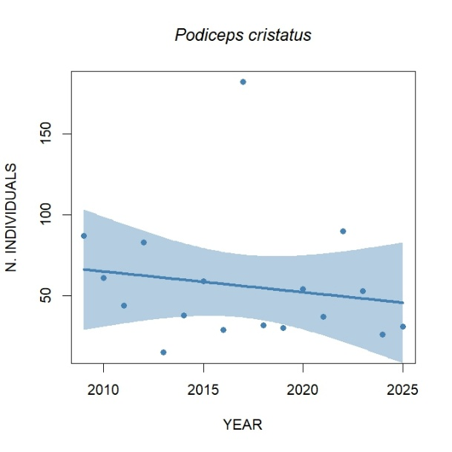 | 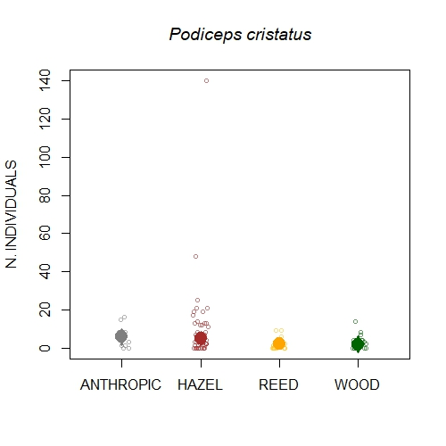
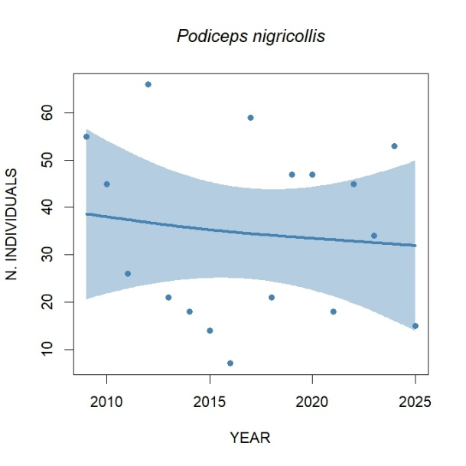 | 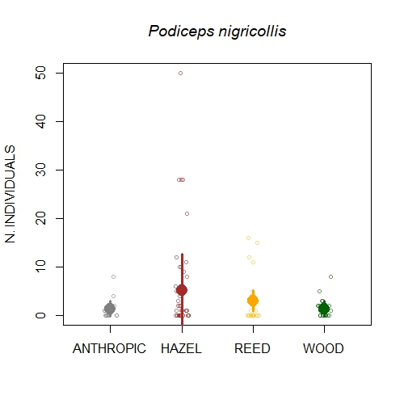
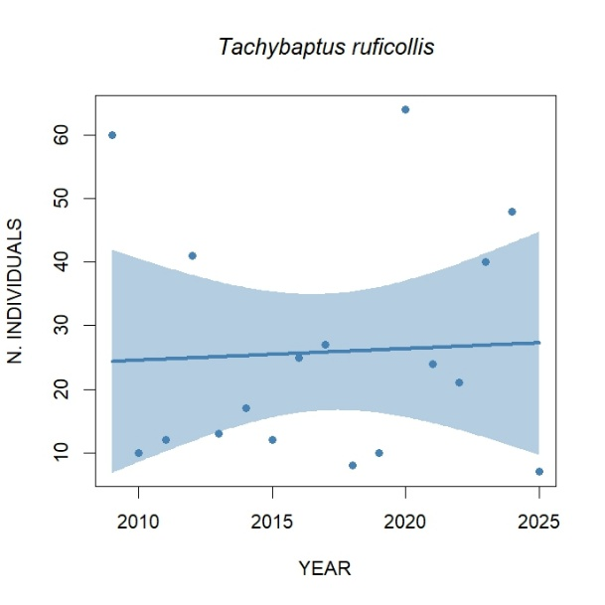 | 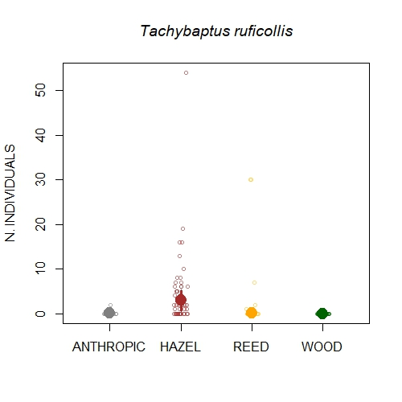
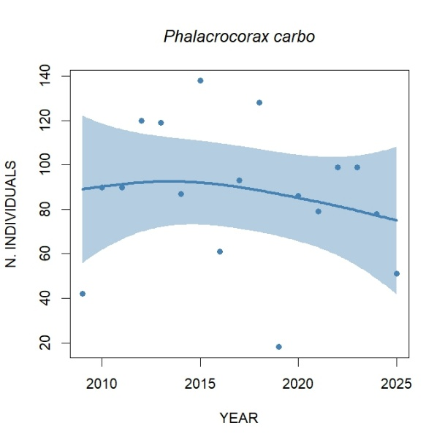 | 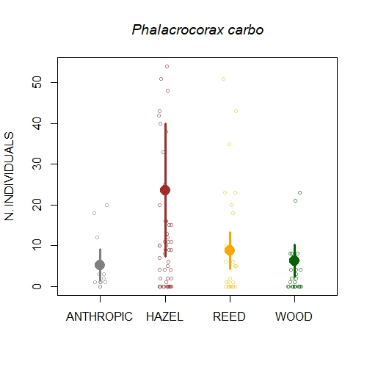
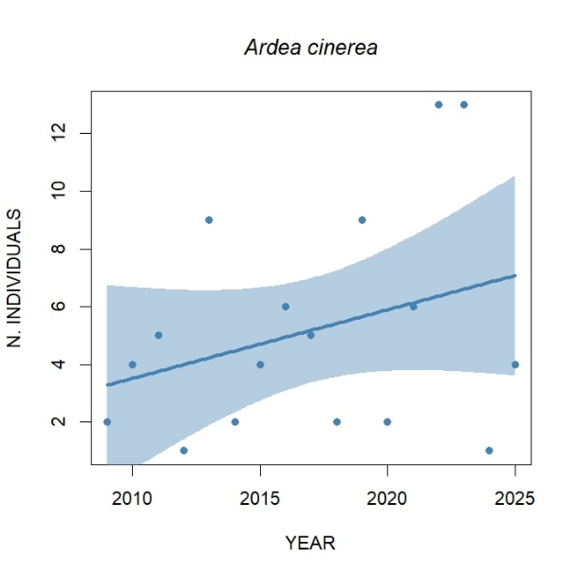 | 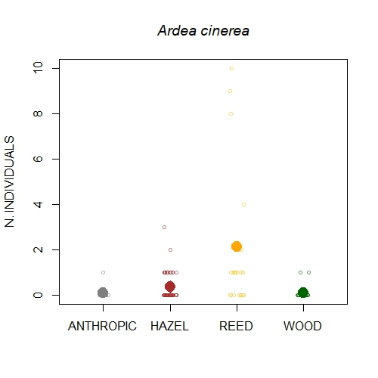
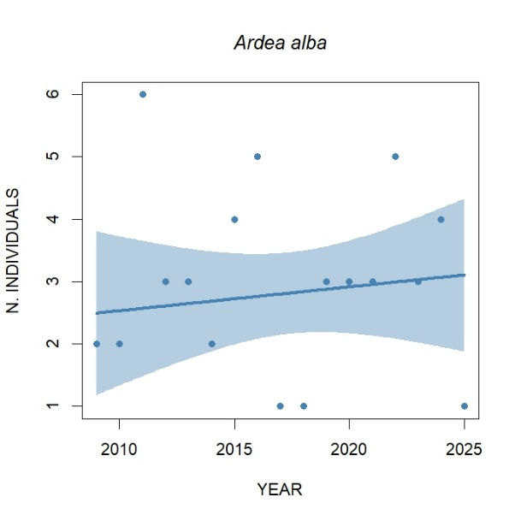
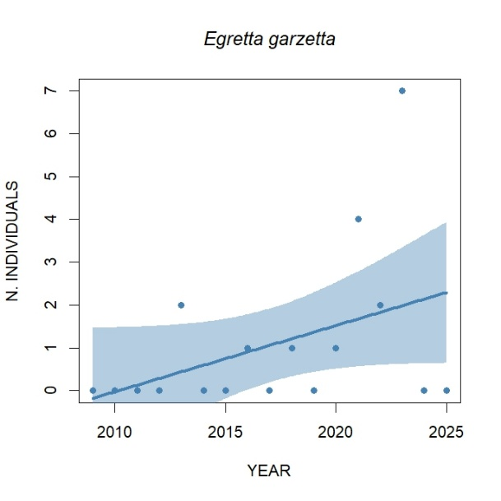
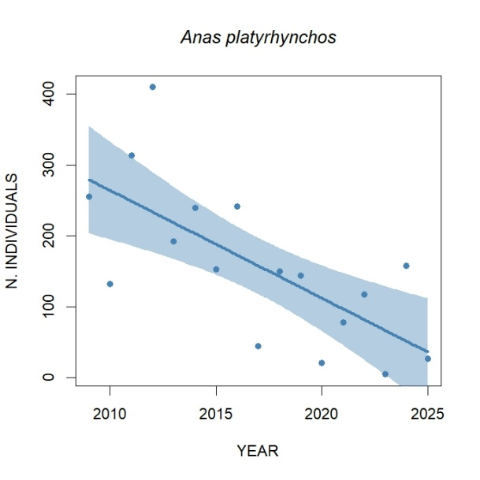 | 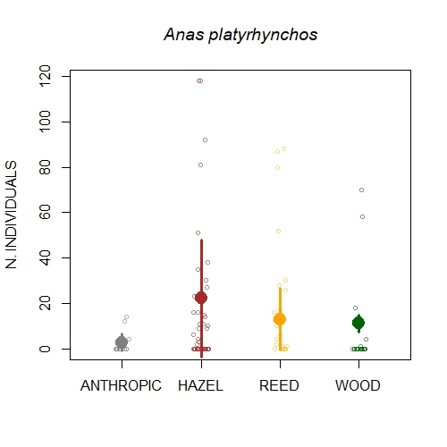
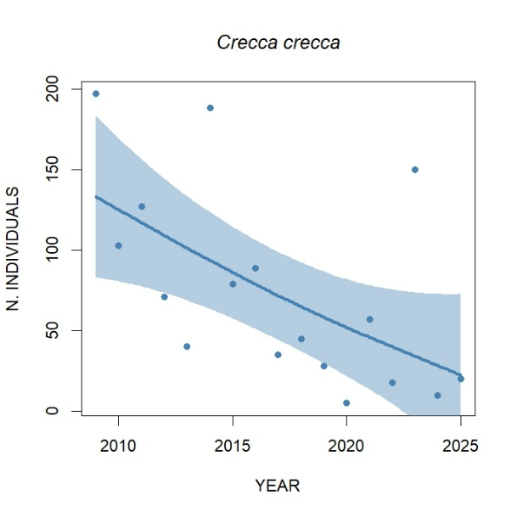 | 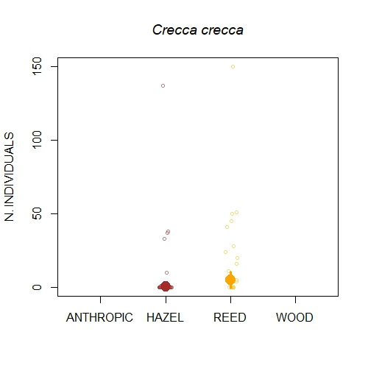
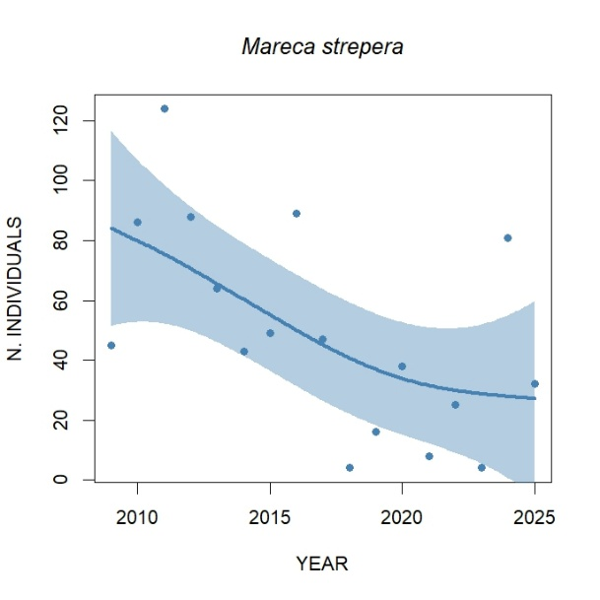 | 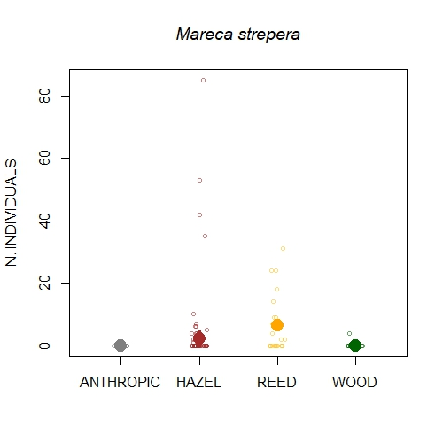
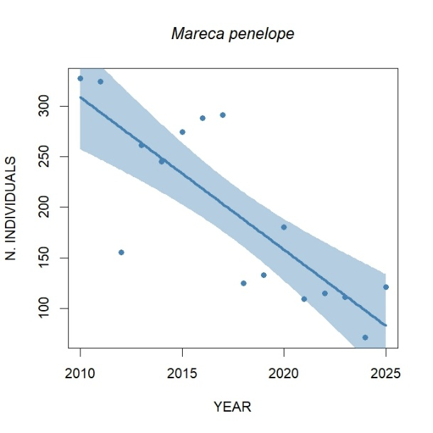 | 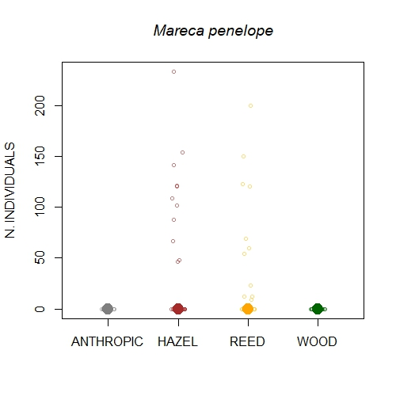
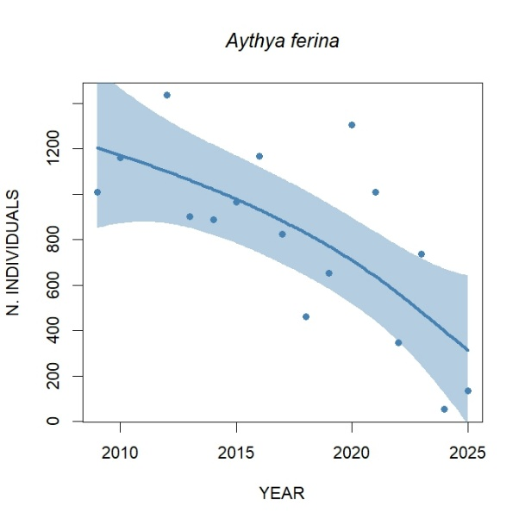 | 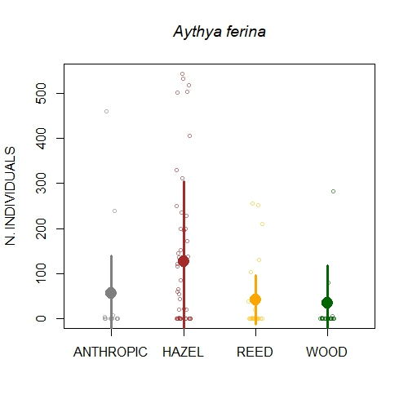
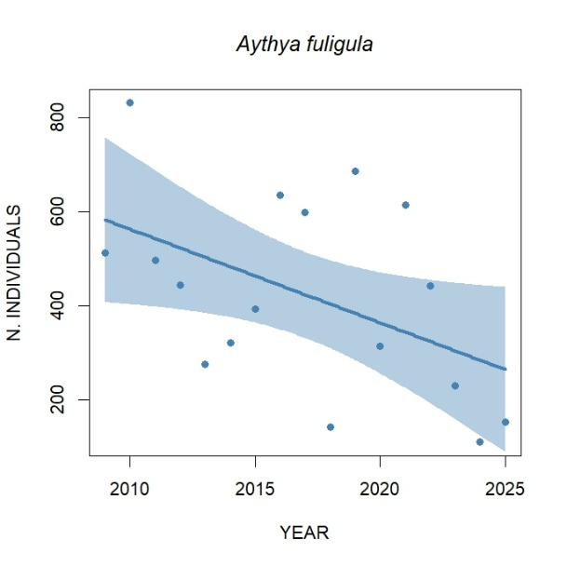 | 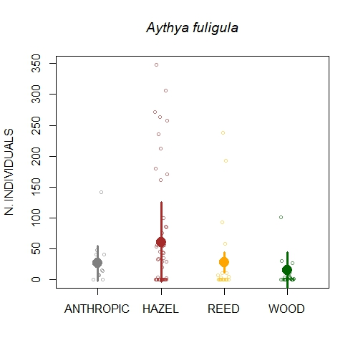
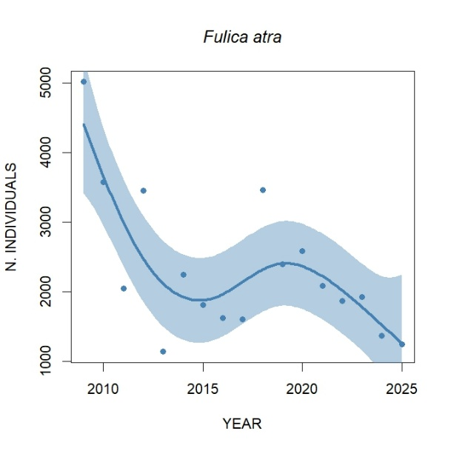 | 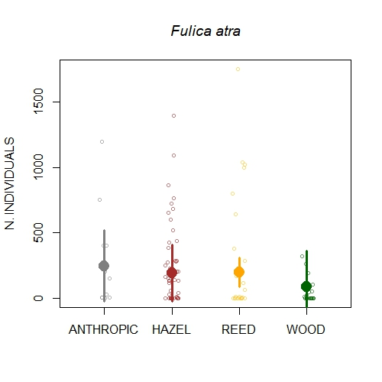
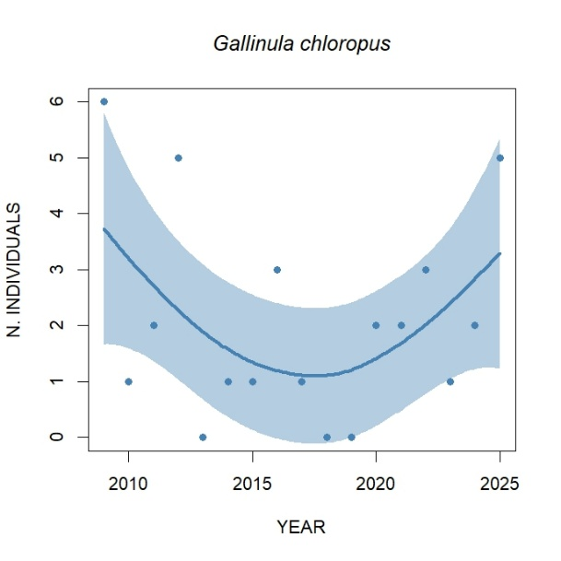
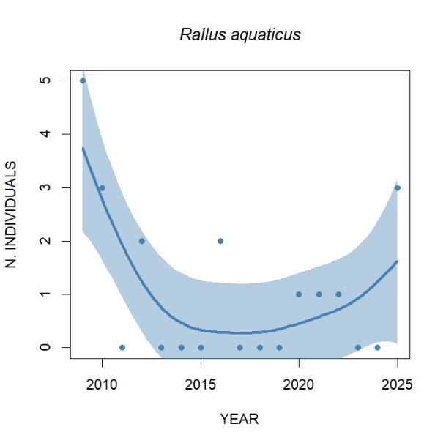
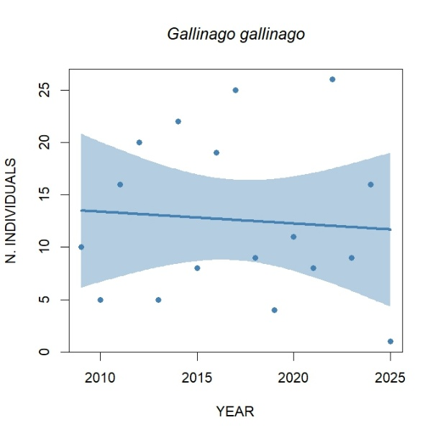 | 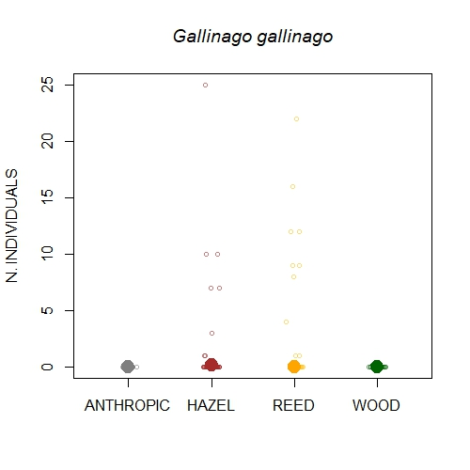
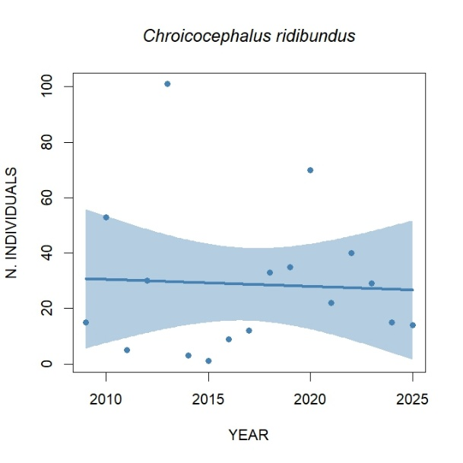 | 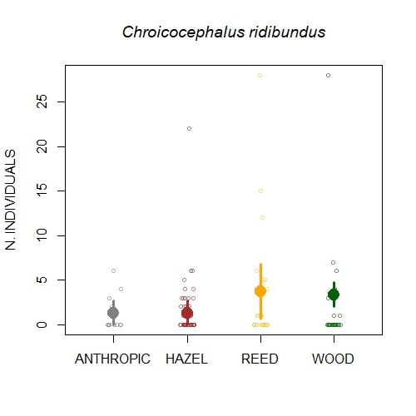
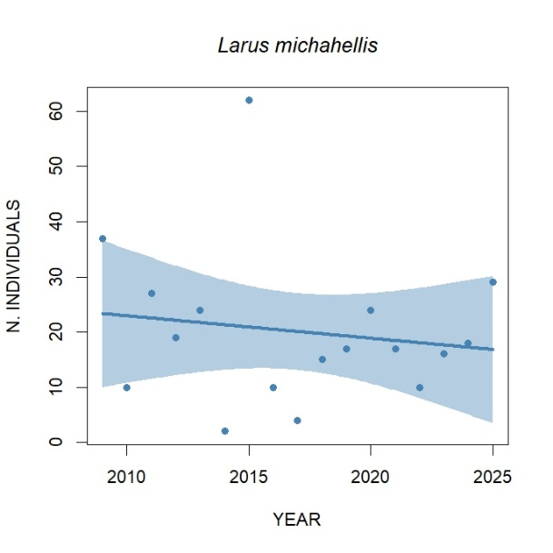 | 