Supplementary Online Material
A NEW PLIOCENE SPERM WHALE FROM VIGLIANO D’ASTI, PIEDMONT, NORTHWEST ITALY

MICHELANGELO BISCONTI, RICCARDO DANIELLO, RICCARDO STECCA &
GIORGIO CARNEVALE

Index
Supplementary Fig. S1 p. 2
Supplementary Fig. S2 p. 3
Supplementary Fig. S3 p. 4
Supplementary Fig. S4 p. 5
Supplementary Text S1 p. 6
Supplementary Table S1 p. 15

Supplementary Fig. S1
Schematic representation of a sperm whale (based on Physeter macrocephalus) showing the preserved bones of MGPT-PU 13864, holotype of Eophyseter damarcoi n. gen. and n. sp, in yellow.

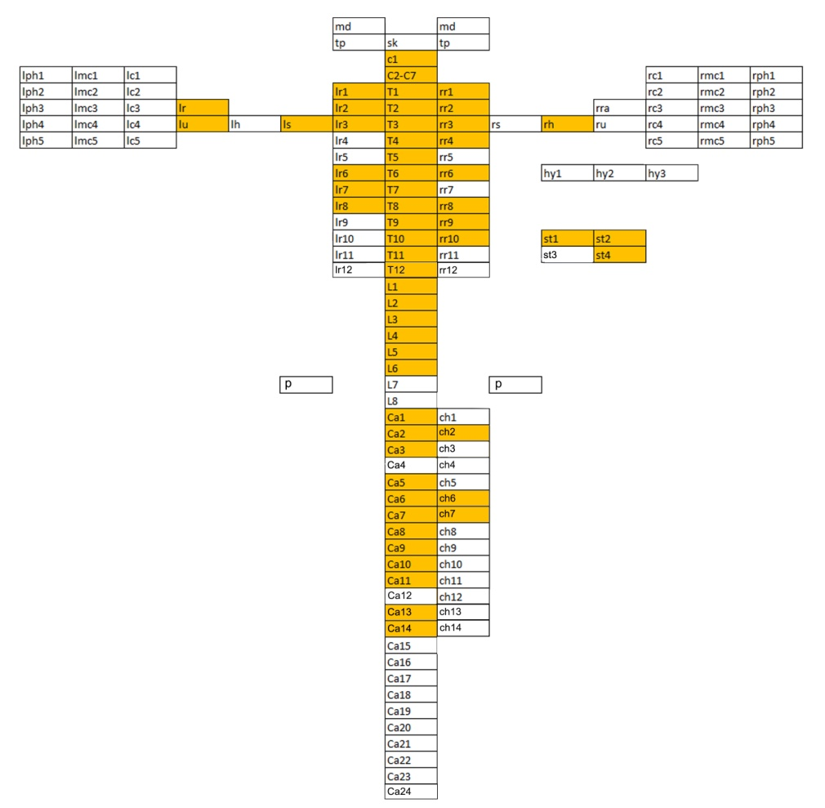

Supplementary Fig. S2
Vertebral dimensions in the extant sperm whale, Physeter macrocephalus, and Neophyseter damarcoi n. gen. and n. sp. A, centrum lengths. B. centrum widths. C, centrum heights.

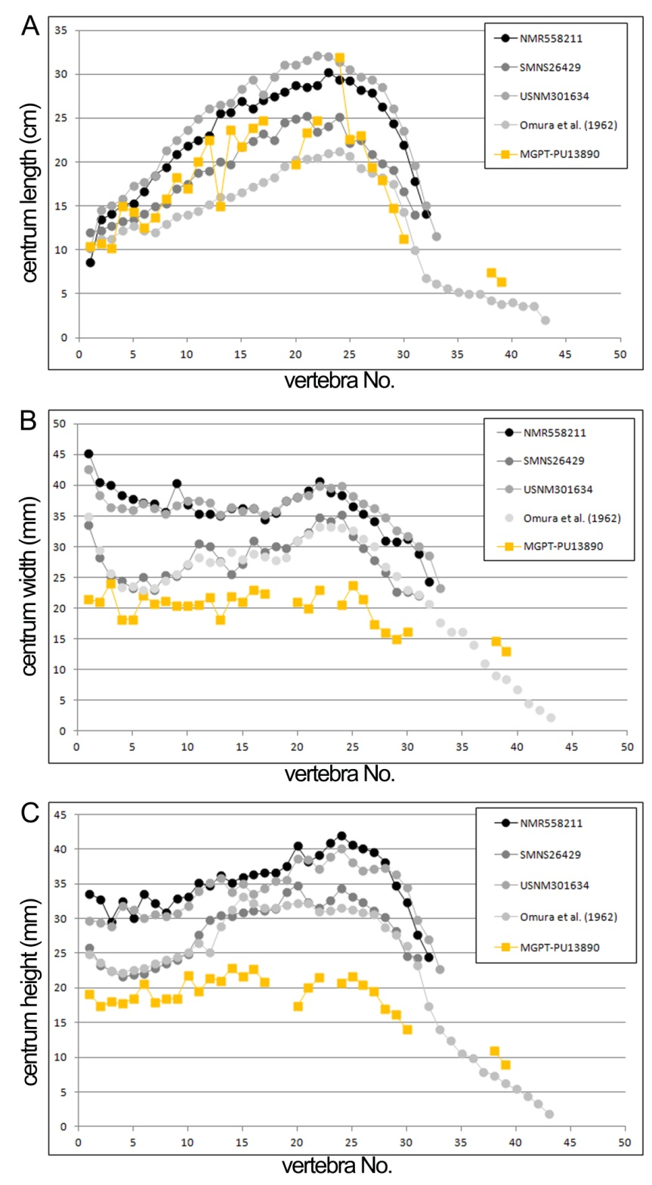

Supplementary Fig. S3
Length vs. height and length vs. width ratios in the extant sperm whales, Physeter macrocephalus (black and grey tones), and Neophyseter damarcoi (in yellow). A, length vs. height. B, length vs. width. Specimens are indicated in the caption. Explanation of acronyms: L, length; W, width. Note that in P. macrocephalus length values are higher than heights and widths but in N. damarcoi this ratio is different.

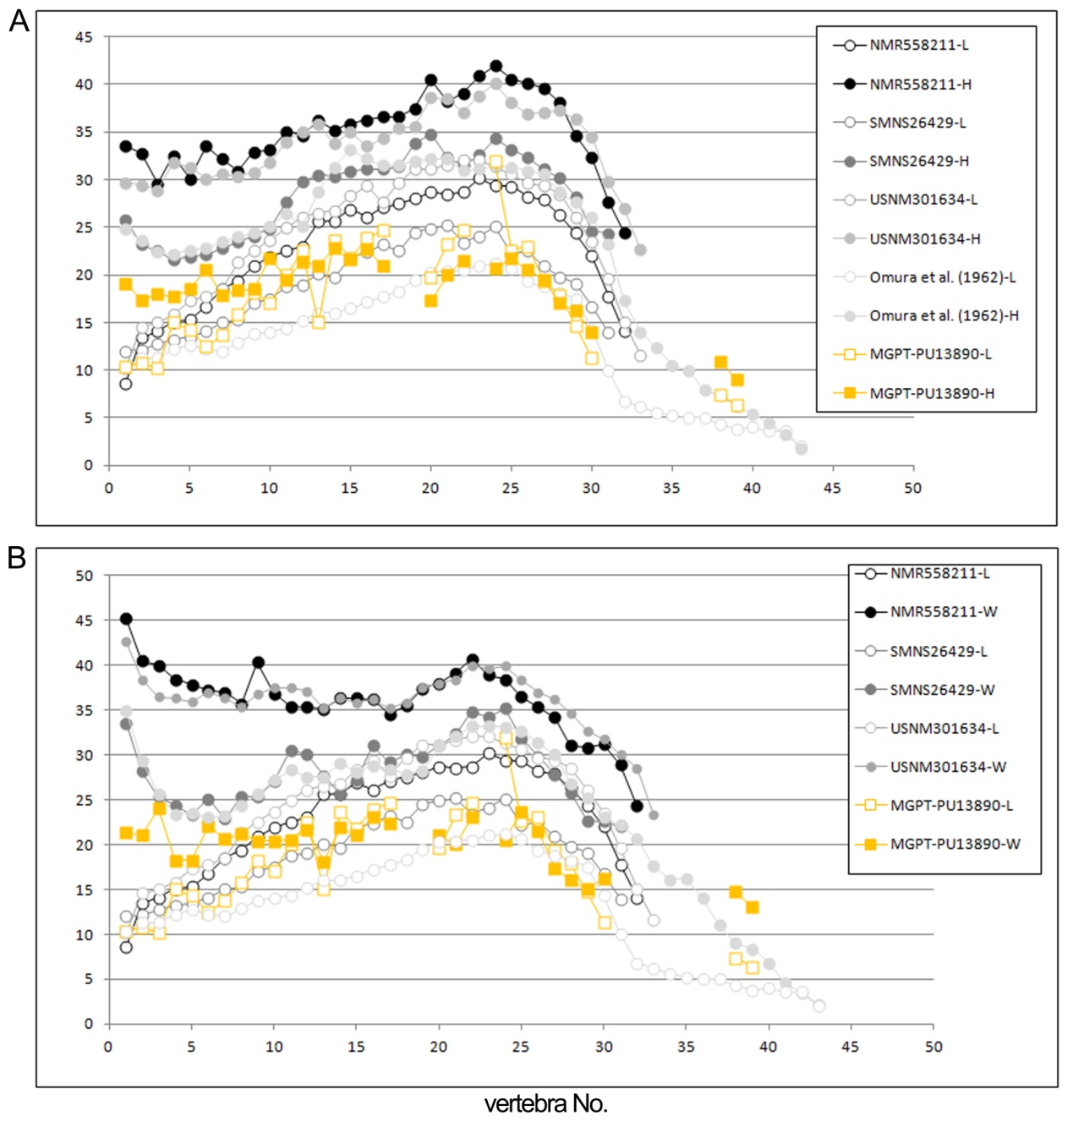

Supplementary Fig. S4
Functional regionalization of the vertebral column of the extant sperm whale, Physeter macrocephalus (in grey tones), and Eophyseter damarcoi (in yellow) based on vertebral indices. A, relative centrum length. B, %change. C, ratio between centrum width and centrum height. Specimens are indicated in the caption. Note that E. damarcoi is divergent from P. macrocephalus in relative centrum lengths and %change values.

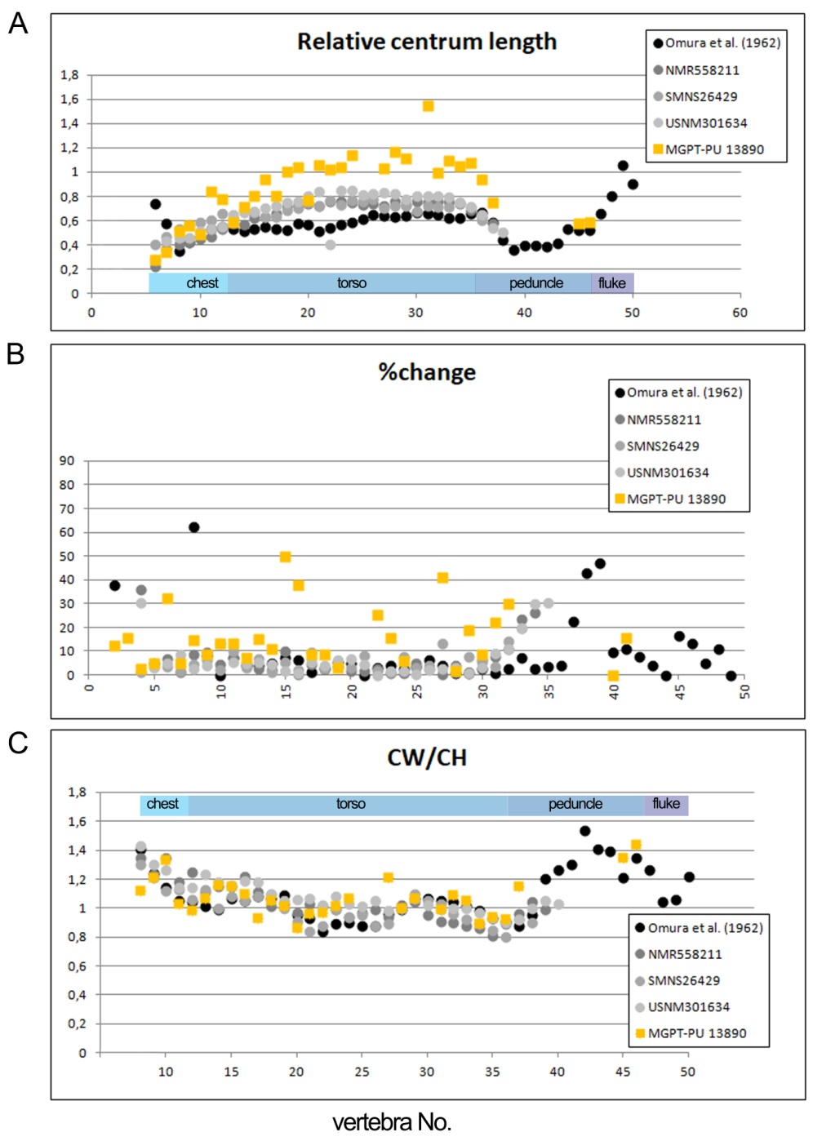

Supplementary Text S1
CHARACTER DESCRIPTIONS FOR PHYLOGENETIC ANALYSIS
As this is the first time that characters from the postcranial skeleton are used in a phylogenetic analysis of Physeteroidea, we feel that a full description of the new characters is necessary to remove any ambiguity and to provide a basis for further discussions. Decisions on the polarizations of the character states are made based on an outgroup comparison criterion (following Lambert et al. 2023 and literature therein).

Character 59
Neural spine of atlas: (0) present but very short; (1) present and long; (2) absent.
Comment: In later archaeocetes like Zygorhiza and Cynthiacetus, the neural spine of the atlas is reduced to a low crest. A long neural spine is present in the atlas of specimens of Physeter macrocephalus but it is apparently absent in others suggesting that this character is subject to some individual variation. The neural spine is absent in the well-preserved atlas of the indeterminate physeteroid previously assigned to Eudelphis mortzelensis and is definitively absent in Eophyseter damarcoi. In Kogia breviceps the neural spine of the atlas is present thus supporting the hypothesis that the presence of the neural spine is plesiomorphic for Physeteroidea.

Character 60
Inferior portion of neural canal of atlas: (0) wide; (1) narrow.
Comment: As shown in Fig. 19, in Physeteridae the neural canal shows a vaguely triangular outline with a narrower and triangular inferior portion. The transverse expansion of this inferior portion may be wide as in specimens of Physeter macrocephalus and Eophyseter damarcoi, or narrow as in other specimens of P. macrocephalus. This size subdivision may be extended to the fossil species in which the ventral portion of is C₁ preserved. In particular, a wide extension is observed in Zygophyseter varolai, Physeterula dubusi, Placoziphius duboisi and the indeterminate physeteroid previously assigned to Eudelphis mortzelensis (Lambert 2008).

Character 61
Neural arch of the atlas: (0) arched; (1) linear.
Comment: The neural arch of the atlas shows two distinctive morphologies in the taxonomic sample examined in the present paper. One of these morphologies is represented by the completely linear outline of the neural arch as observed in P. damarcoi and SP P. macrocephalus (Fig. 25A, C). The other morphology is observed in NP P. macrocephalus where the lateral portions of the neural arch projects dorsally and medially, thus forming an arched neural arch. Such a morphology is observed also in Eodelphis mortselensis suggesting that the arched neural arch may be a plesiomorphic character state for Physeteridae (Abel 1905). Comparisons with Kogia breviceps are more difficult because in this species all the cervical vertebrae are fused together; however, as far as the overall morphology of the neural arch is concerned, in K. breviceps the neural arch is evidently arched (Omura et al. 1984), therefore providing further support to the hypothesis that an arched neural arch of the atlas is a plesiomorphic state for Physeteridae.

Character 62
Ventral surface of axis in posterior view: (0) highly convex and triangular; (1) slightly convex-to-flat.
Comment: We observed two different outlines of the ventral surface of the axis: a highly convex outline and a slightly convex outline. These shapes are used to describe substantially different outlines of the vertebral centra in posterior and anterior view in the block including the axis. Highly convex and triangular ventral surface is related to a higher position of the transverse process and a narrower transverse diameter of the vertebral centra.

Character 63
Neural spine of axis: (0) present; (1) absent.
Comment: Presence and absence of the neural spine of the axis may be an indication of the shape and orientation of the tendons that maintain the position of the skull. Absence and presence of the neural spine indicate different functional strategies for head suspension in different species or event populations, as is the case of the extant NP P. macrocephalus which lacks the neural spine in the axis-bearing cervical block. Presence of the neural spine on the axis is considered a plesiomorphic state because it is shared with Kogia breviceps (Omura et al. 1984). The plesiomorphic state for the whole dataset is that shown by later archaeocetes in which the neural spine of the axis is high (Kellogg 1936; Martínez-Cáceres et al. 2017).

Character 64
Width of axis in anterior view: (0) narrow (height/width ratio equals c. 1); (1) wide (height/width ratio equals c. 0.5).
Comment: As shown in Fig. 26, the proportions of the axis-bearing cervical block may differ among different individuals of the extant P. macrocephalus. Presently, we cannot exclude the diagnostic potential of this character and include it in our morphological dataset. The peculiar proportions of the axis-bearing cervical block of some extant individuals are largely different from those of others and N. damarcoi and from those of the few fossil species for which the corresponding skeletal portion is preserved. In any case, the outgroup comparison criterion suggests that a narrow axis in anterior view is plesiomorphic for the whole Neoceti because a it is present in later archaeocetes like Zygorhiza and Cynthiacetus (Kellogg 1936; Martínez-Cáceres et al. 2017).

Character 65
Posterior epiphysis of axis-bearing block (C₇): (0) narrow (height/width ratio equals c. 0.65); (1) wide (height/width ratio equals c. 0.45).
Comment: In Fig. 26D, E, the posterior articular face of the centrum of C₇ is shown in an individual from one of the northern populations of P. macrocephalus and N. damarcoi. It is evident that the outline of this centrum is largely different in these two individuals being transversely narrow and heart-shaped in the former (height:width ratio equals 0.45) and wide and elliptical in the latter (height:width ratio equals 0.675). These shapes may be thought as indications of different articulation patterns of the cervical vertebrae with the anterior-most thoracic vertebra suggesting systematic and phylogenetic separation between the extant species and the Pliocene N. damarcoi.

Character 66
Inferior portion of neural canal of axis: (0) wide (height/width ratio equals to c. 1); (1) narrow (height/width ratio ≥ 2).
Comment: The neural canal of the axis includes a superior portion that allows the spinal cord to pass through and an inferior portion which is posteriorly closed by the centrum of C₃. The superior and the inferior portions are clearly identified because of a sharp narrowing of the outline of the neural canal that allows to measure the height of the ventral portion. The transverse width was measured at the middle of the height of the ventral portion. Based on these observations and measurements, the ventral portion may be narrow and triangular (height/width ratio ≥ 2) or high and squared (with rounded corners; height: width ratio equals to c. 1). We observed these differences in the different individuals of the extant P. macrocephalus (Fig. 26A characterized by height/width ratio = 0.88, and B characterized by height/width ratio = 0.9) and we noticed that these morphologies are differently distributed along the axes of the fossil species in which this vertebra is preserved. Therefore, given the phylogenetic potential of these shapes, we included the outline of the inferior portion of the neural canal of the axis in our phylogenetic analysis. A narrow ventral portion is observed in Fig. 26 B, Eophyseter damarcoi, that is characterized by a height/width ratio = 2.8. A wide inferior portion of the neural canal of the axis is observed in both Zygorhiza and Cynthiacetus thus supporting the hypothesis that a wide inferior portion of the neural canal is plesiomorphic for Neoceti.

Character 67
Neural canal of axis in anterior view: (0) high and triangular or round; (1) low and rectangular.
Comment: A superiorly round and high neural canal of the axis is probably a plesiomorphic character state in Physeteridae as it is shared with Kogia breviceps (Omura et al. 1984) and the early-diverging physeteroid Cozzuoliphyseter rionegrensis (Paolucci et al. 2020). We observed that NP and SP P. macrocephalus and P. damarcoi exhibit different outlines of the neural canal of the axis and acknowledged the phylogenetic potential of this character by an outgroup comparison criterion accepting the state exhibited by Kogia breviceps and Cozzuoliphyseter rionegrensis as the plesiomorphic state.

Character 68
Extent of supraspinous fossa of scapula: (0) wide (angle between cranial margin and scapular spine > 20°); (1) narrow (angle between cranial margin and scapular spine < 30°).
Comment: The shape of the supraspinous fossa of the scapula is different in different physeteroid taxa. The extent of the supraspinous fossa depends upon the angle between the cranial border of the scapula and the scapular spine. We measured this angle in the different specimens we used in this analysis and found that anteroposteriorly elongated supraspinous fossae are characterized by an angle >20°. We observe an angle > 20° in later archaeocetes (Zygorhiza = 42.4°, Basilosaurus cetoides = 76°, Cynthiacetus peruvianus = 69°). In the outgroup Kogia breviceps the supraspinous fossa is anteroposteriorly elongated as it shows a basal angle of 84°. In Brygmophyeter shigensis the basal angle is 36° that is very close to that of some individuals of Physeter macrocephalus (Fig. 26A and B with angles of 35. In the B. shigensis, the inferior portion of the supraspinous fossa is hidden by the anterior extent of the scapular spine. A very narrow supraspinous fossa is observed in the scapula of Eophyseter damarcoi (angle = 19.6°). Based on this comparison, we suggest that a wide supraspinous fossa is a plesiomorphic character state for Physeteroidea. A wide supraspinous fossa is observed in the later archaeocetes and this condition is then changed in later Neoceti as shown by Bisconti & Carnevale (2022) in which the supraspinous fossa is reduced even to become absent to the sight in lateral view.

Character 69
Superior border of acromion: (0) mostly linear; (1) mostly concave.
Comment: The acromion shows different morphologies in physeteroids. In the outgroup Kogia breviceps it is grossly rectangular, projects anteroventrally and lacks the anterior expansion. NP and SP Physeter macrocephalus exhibit small differences in the superior border of the acromion that may be interpreted as intraspecific variation. However, the acromial morphology observed in Physeter damarcoi closely matches that of SP P. macrocephalus suggesting that the differences may represent diagnostic characters for the different populations of the extant P. macrocephalus. The acromion is also preserved in Zygophyseter varolai in which it is broadly rectangular (Bianucci & Landini 2006) and lacks the evident concavity in the superior border observed in SP and P. damarcoi. Based on the outgroup comparison criterion, we suggest that the rectangular acromion is a plesiomorphic state and that the concave superior border of the acromion is derived. This suggestion is even further corroborated by the observation that the acromion in Zygorhiza and Cynthiacetus is rectangular with slightly concave superior edge (Kellogg 1936; Martínez-Cáceres et al. 2017).

Character 70
Posterior edge of humerus: (0) posteriorly straight; (1) posteriorly concave.
Comment: The increase of the curvature of the posterior edge of the humerus seems a common pattern in cetacean evolution as it is observed that more recent species are characterized by a more concave posterior edge of the humerus and that more archaic species (including archaeocetes) show that this portion is more linear (Bisconti & Carnevale 2022; Bisconti et al. 2023; Lavigerie et al. 2021; Kimura et al. 2006). This pattern is observed also in physeteroids as partially shown by Kimura et al. (2006) and Fig. 27 of the present paper. In Kogia breviceps and K. sima the posterior border of the humerus is scarcely concave suggesting that a straight outline of this humeral portion is plesiomorphic in Physeteroidea. In later archaeocetes like Zygorhiza kochii and Cynthiacetus peruvianus the posterior edge of the humerus is linear confirming that a straight outline is plesiomorphic for neocete cetaceans.

Character 71
Relative height of the ulnar epicondyle of humerus: (0) visibly higher than the ulnar articular facet; (1) close to the ulnar articular facet.
Comment: The height of the ulnar epicondyle may be related to the relative development of the olecranon of the ulna and to the inclination of the posterior articular surface of the ulnar proximal epiphysis. We observe that a high epicondyle is absent in both NP and SP P. macrocephalus but is present in P. damarcoi. Unfortunately, the olecranon of P. damarcoi is lost and we cannot make comparisons about this structure. Peri et al. (2020) showed that a high placement of the olecranon is present in an indeterminate physeteroid from the late Miocene of southern Italy (MSNUP I-17076). In this specimen the inclination of the articular facet for the humerus of the ulna is more inclined than in the extant SP and NP P. macrocephalus suggesting a higher position for the ulnar epicondyle. A high epicondyle together with highly inclined articulation facets for the ulna are observed in humeri referred to Aulophyseter morricei and in Brygmophyseter shigensis (Kimura et al. 2006). As in Kogia breviceps the ulnar epicondyle of the humerus is located in the distal part of the bone, we suggest that a high epicondyle may represent a derived state. The epicondyle of the humerus moves distally among neocetes even in some species (like Physeter damarcoi) it maintains a higher position with respect to other, more recent ones (like SP P. macrocephalus). In later archaeocetes, the distal extremity of the humerus is circular in outline and describes a half circle in lateral view. For this reason the ulnar epicondyle of the humerus is high in both Zygorhiza kochii and Cynthiacetus peruvianus (Kellogg 1936; Martínez-Cáceres et al. 2017).

Character 72
Anterior projection of the distal epiphysis of humerus: (0) absent; (1) small; (2) large.
Comment: This character is related to the degree of the torsion of the distal portion of the humerus with respect to the proximodistal axis of the bone. Benke (1987) shows that in most odontocetes the humerus shows a longer diameter along the anteroposterior axis in its proximal portion but in the distal portion the longest diameter is along an approximately transverse axis. This suggests that a sort of torsion can be observed in the humerus of at least some cetacean species. Kogia breviceps and K. sima show this kind of torsion with the distal portion of the humerus more wider along the transverse axis. Such a projection is manifested through a triangular expansion of the distal and medial corner of the bone. In extant physeterids, Physeter damarcoi and in the fossil humera referred to Aulophyseter morricei and in Brygmophyseter shigensis the torsion is minimal and the distal portion of the humerus projects anteriorly through a protruded and triangular anterodistal corner. The relative size of this protrusion is assessed here: in Physeter damarcoi the distal protrusion is relatively small and this state is shared with Brygmophyseter shigensis and Aulophyseter morricei. In extant SP P. macrocephalus the projection is large and higher. In later archaeocetes, the distal epiphysis of the humerus does not protrude anteriorly at all (Kellogg 1936; Martínez-Cáceres et al. 2017).

Character 73
Shape of deltopectoral crest of humerus: (0) convex-to-linear; (1) anteriorly concave.
Comment: The deltopectoral crest is long and protruding in all physeteroids and in later archaeocetes like basilosaurids (Bisconti & Carnevale 2022). The peculiar shape of this crest as observed in the extant NP and SP Physeter macrocephalus is typical of the modern species and is only rarely observed in the fossil record. In particular, Kimura et al. (2006) shows that an anteriorly concave deltopectoral crest is present in two humera referred to Aulocetus morricei. However, in all the other humera figured in the Kimura et al.’s (2006) paper, including that of Brygmophyseter shigensis, the deltopectoral crest is linear-to-slightly convex. In Physeter damarcoi the deltopectoral crest is linear. An anteriorly convex deltopectoral crest is present in Kogia breviceps and K. sima thus reinforcing the hypothesis that a convex-to-straight deltopectoral crest in lateral view is plesiomorphic for Physeteroidea. A further corroboration of this hypothesis derives from the presence of a straight deltopectoral crest in later archaeocetes like Zygorhiza kochii and Cynthiacetus peruvianus.

Character 74
Anterior protrusion of deltoid tubercle of humerus: (0) absent; (1) present.
Comment: An anteriorly protruding deltoid tubercle of the humerus is observed in both NP and SP Physeter macrocephalus and in Aulophyseter morricei. It is possible that the anterior projection of the deltoid tubercle is related to the emergence of the concavity in the deltopectoral crest, but for the moment, we prefer to treat these two anatomical structures separately but will look for correlation based on the reconstruction of ancestral states. In Brygmophyseter shigensis the deltoid tubercle is not observed at all probably due to some erosion of the whole deltopectoral crest. In Physeter damarcoi the deltoid tubercle points inferiorly and is scarcely observed in lateral view. Interestingly, the deltoid tubercle of the humerus is not individuated as a distinctly morphological entity in later archaeocetes thus reinforcing the hypothesis that the absence of protrusion represents a plesiomorphic state.

Character 75
Radius robustness: (0) not robust (proximodistal diameter:anteroposterior diameter > 2.6); (1) robust (proximodistal:anteroposterior diameters < 2.5).
Comment: Bisconti et al. (2023) provided a quantitative analysis of the radius robustness in Balaenoidea including extant and fossil Balaenidae and Neobalaenidae. Such a quantitative analysis is not useful here because of the paucity of preserved radia in fossil physeteroids. However, the main concept of the Bisconti et al.’s (2023) analysis was that a robust radius is one in which the anteroposterior diameters of the radius taken at mid-length and at the distal epiphysis represent a high percentace of the radial length. In the present paper we limit our observation to the morphological differences observed in the radius of those individuals of the extant Physeter macrocephalus represented in Fig. 27A, B, Eophyseter damarcoi (Fig. 27C) and MSNUP I-17076. From a qualitative point of view, the visual analysis of the radia of these individuals clearly show that in extant P. macrocephalus the radius slooks more robust because its anteroposterior diameters at both mid-length and distal epiphysis are comparatively longer (proximodistal:anteroposterior diameters < 2.5) than those observed in N. damarcoi and MSNUP I-17076 (proximodistal:anteroposeterior diameters respectively of 2.84 and 3.15). In later archaeocetes the radius is not robust and it is elongated but anteriorly convex.

Character 76
Radial process: (0) well-developed; (1) reduced to a radial crest; (2) absent.
Comment: As shown by Bisconti & Carnevale (2022), in later archaeocetes, the radial process is a well-developed and rod-like structure that projects anteriorly from a point located approximately at the middle of the radial length. In subsequent neocete cetaceans, the radial process is variously reduced to a simple convexity of the anterior edge of the radius. Such an edge may be more or less evident in lateral view. As an example, in Physeter damarcoi the convexity in the anterior edge of the radius is less evident than in SP P. macrocephalus whereas in NP the convexity supposed to correspond to the radial process is present but scarcely developed. Kellogg (1936) and Martínez-Cáceres et al. 2017) showed the presence of a well-developed radial process anteriorly protruding from the anterior edge of the radius in both Zygorhiza kochii and Cynthiacetus peruvianus. The position of the radial process is in the proximal portion of the radius matching the position of the anterior convexity of the radius as observed in later neocete cetaceans (Bisconti & Carnevale 2022). Presence of a well-developed radial process can be thus considered the plesiomorphic state for neocetes as a whole.

Character 77
Ulna robustness: (0) slender (proximodistal diameter/anteroposterior diameter ≥ 3); (1) intermediate robustness (proximodistal/anteroposterior diameter < 3 and > 2); (2) robust (proximodistal diameter/anteroposterior diameter ≤ 2).
Comment: The same arguments as those about the robustness of the radius apply to the robustness of the ulna. We observe a different morphology in the ulna of different individuals of Physeter macrocephalus and an additional different morphology in Eophyseter damarcoi. However, as far as the robustness is concerned, the ulna P. macrocephalus is the more elongated anteroposteriorly at both the distal epiphysis (ratio = 1.22 for the specimen described by Flower, and 1.2 for the specimen described by Van Beneden & Gervais 1880) and mid-length (ratio = 2.17 for both the specimens figured by Flower and Van Beneden & Gervais) and is thus considered being the most robust. In a different specimen of P. macrocephalus (figured by Omura et al. 1968) the ulna is more slender and its anteroposterior diameter is visibly shorter at mid-length (ratio = 3; at distal end the ratio is 1.5) than that of the other P. macrocephalus discussed above. In Eophyseter damarcoi the ulna has a different outline of the posterior edge and its anteroposterior diameter is comparatively longer at mid-length (ratio = 2.45; ratio at distal end = 1.74) than in the more robust P. macrocephalus and is considered representing an intermediate degree of robustness in the present paper. A slender ulna is observed in the indeterminate physeteroid MSNUP I-17076 that shows a ratio at mid-length of 4.5. In later archaeocetes the ulna does not show any anteroposterior expansion that may be considered somewhat similar to that observed in later neocetes such as Physeteridae. In later archaeocetes the ulna is a slender bone with a straight-to-moderately arched posterior edge. Interestingly, as shown by Kellogg (1936) and Martínez-Cáceres et al. (2017), there is no articulation facet between radius and ulna at both proximal and distal positions in later archaeocetes.

Character 78
Outline of capitulum in first rib: (0) flat; (1) convex.
Comment: The capitulum of the first rib is dorsally convex and elongated in Kogia breviceps (Omura et al. 1984) and in early-diverging physeteroid like Zygophyseter varolai and Rhaphicetus valenciae (Bianucci & Landini 2006; Lambert et al. 2020) thus suggesting that a rounded and convex capitulum is typical for Physeteroidea. NP Physeter macrocephalus shows a flat capitulum whereas Physeter damarcoi and SP P. macrocephalus shows a convex capitulum. In later archaeocetes, tuberculum and capitulum of the first rib shows similar morphologies: both exhibit flat articular surfaces located at the proximal end of a rectangular neck; a triangular space is interposed between the necks bearing tuberculum and capitulum. The convex and round shape of the capitulum of the first rib of P. damarcoi, SP P. macrocephalus, Z. varolai and R. valenciae seems a secondary modification suggesting that a flat articular surface is plesiomorphic for Neoceti. For this reason, we coded a flat outline as plesiomorphic and a convex outline as apomorphic. This may represent an apomorphy of Physeteroidea.

Character 79
Relative development of the tubercle for the iliocostal muscle in first and second rib: (0) well-developed; (1) not developed.
Comment: In Kogia breviceps the tubercle for the iliocostal muscle is well-developed and protrudes laterally assuming a triangular shape (Omura et al. 1984). In NP Physeter macrocephalus the tubercle is well-developed and protruding especially in the second and third rib (Omura et al. 1962). In Physeter damarcoi such a protrusion is not observed and for this reason it is estimated that the iliocostal muscle was developed at a lesser extent when compared to the extant P. macrocephalus and K. breviceps. The presence of a well-developed and triangular tubercle for the iliocostal muscle is observed also in Zygorhiza kochi thus corroborating the hypothesis that this state is plesiomorphic for Physeteroidea too.

Supplementary Table S1
CHARACTER X TAXON MATRIX USED FOR PHYLOGENETIC ANALYSIS
Zygorhiza kochii
000000000 -?000---00 --000-0000 2000000000 00-0000000 0?0?-0--? 000000000000000000000
Cynthiacetus peruvianus
000000010 -?000---00 --000-0000 2010001000 00-00000?0 0000-0--0 000100000000000001001
Agorophius pygmaeus
??0100?01 -000000000 -0?0100000 0??????0?? ?1000?0??? ????-0--? ?????????????????????
Eudelphis mortezelensis
101?00?11 001??01?1? 0??????100 ?1????00?? ???????0?? ?????03?2 000??????????????????
Zygophyseter varolai
101100121 0211011211 1?10010110 ?12?111010 1100?00?2? 011?11?0? ?0?????0??0????????10
Brygmophyseter shigensis
??1??0?21 021101??1? ????110110 1????1101? 1???0????? 0??1?0??? ?????????1010100010?1
Acrophyseter deinodon
20110001? 03?100111? 10??020110 1?20111010 11??0?0120 11??11?02 ?????????????????????
Acrophyseter robustus
001100002 02110?0110 1010020110 1???1?102? 110?0001?? 1?111010? ?????????????????????
Acrophyseter sp
001100012 0????0??1? ????0?0110 ??????10?0 11?0??01?? 1????0??? ?????????????????????
Livyatan melvillei
212110132 02?1?0???? 0?1?1201?0 ??????1001 110?0?1??? ?1??10??? ?????????????????????
Cozzuoliphyseter rionegrensis
?01100011 0111000111 00?0110110 1???????2? 12001?0??? 0???00211 0001?0000????????????
Orycterocetus crocodilinus
101100011 0111010111 01?0111110 222011012? ?20?001011 ????00300 ?????????????????????
Physeterula dubusi
??10?0?21 021101??1? 00??11?110 22????0121 ??000??0?? 01?????0? ?0??????????????????0
Idiorophus patagonicus
001100021 0????????? 0???11???? ??????0121 ??0?0????? 0????0??? ?????????????????????
Diaphorocetus pouchetii
??1100?12 0?110111?? 0???1?1100 ????????2? ?20?0?10?? ????01311 ?????????????????????
Placoziphius duboisii
?0120??11 0?110111?1 0??011?110 ?2???????? ?20????0?? ??0??03?1 ?00??????????????????
Aulophyseter morricei
101001-21 0211010211 0010222110 2?201?01?? ?200??1010 ????0011? ???????????00211?????
Physeter macrocephalus (Omura et al. 1962)
402251-31 0311010211 0010222110 2220110121 8200111011 010210000 000011111001111111101
Physeter macrocephalus (Flower 1868)
402251-31 0311010211 0010222110 2220110121 8200111011 010210000 211?00?0011112111111?
Physeter macrocephalus (Van Beneden & Gervais 1880)
402251-31 0311010211 0010222110 2220110121 8200111011 010210000 0000011101111111122??
Physeter macrocephalus (MSNUP 265)
402251-31 0311010211 0010222110 2220110121 8200111011 010210000 ?????????1101110122??
Idiophyseter merriami
?????1?1? 02110?121? 0???221??? 2????????? ?????????? ?????010? ?????????????????????
Thalassocetus antwerpiensis
??6????01 011?0????1 0???119110 5????????? ??011????? ????0??0? ?????????????????????
Aprixokogia kelloggi
??2?00?01 001111021? 0?11210111 22???????? ?1110?10?? ????1010? ?????????????????????
Scaphokogia cochlearis
?11111-02 0010110212 0111219101 3?211????? ?1100?1??? ????1010? ?????????????????????
Praekogia cedrosensis
??1????02 10101???12 01?1?11102 12???????? ??111?10?? ????1??0? ?????????????????????
Kogia spp. (K. breviceps + K. sima)
212201-02 1010110412 0111222102 5221110161 8211121021 22?210100 100-00?--100010011111
Koristocetus pescei
211200102 131011??12 0?11?10112 1????????? ?2100?1??? ????101?? ?????????????????????
Nanokogia isthmia
211101-02 101011??12 0110210102 12????0?11 ?1101210?? 01??1010? ?????????????????????
Platyscaphokogia landinii
?11110102 0010110212 011121???? 3????????? ?2100????? ????1020? ?????????????????????
Pliokogia apenninica
??1?0?-02 101011021? 0??121???? ???????1?? ??1?1????? ????10??? ?????????????????????
Thalassocetus sp.
??1????01 01110?0011 01?0111110 5????????? ??0?1????? ????0?10? ?????????????????????
Angelocetus cursiensis
4?6????11 07110???11 01???1??00 2?????00?? 18??1????? ????0?10? ?????????????????????
Rhaphicetus valenciae
0?1000?11 02?1?0021? 0010000900 1?2011002? ?200100010 09??00?10 ???????????????????1?
Kogia danomurai
??2??1?01 13101???12 0110211??? 2????????? ??1?0????? ????1?10? ?????????????????????
Miophyseter chitaensis
??1200111 0211010?10 0?101?1??? 22201100?? ?2010??011 ??0?0?10? ?????????????????????
Scaphokogia totajpe
211111102 0010110112 0110210111 22????01?? ?2111?1??? ????1010? ?????????????????????
Diaphorocetus ortegai
4?1700?13 0?11011214 00??1??100 05????0?2? ?20?0????? ????01211 ?????????????????????
Physeter damarcoi
????????? ?????????? ?????????? ?????????? ?????????? ????????? 211100111110010011111

